**Types of Neural Network**

There are many types of neural network but top 5 are ;-

**1. Multi-layer Perceptron MLP**

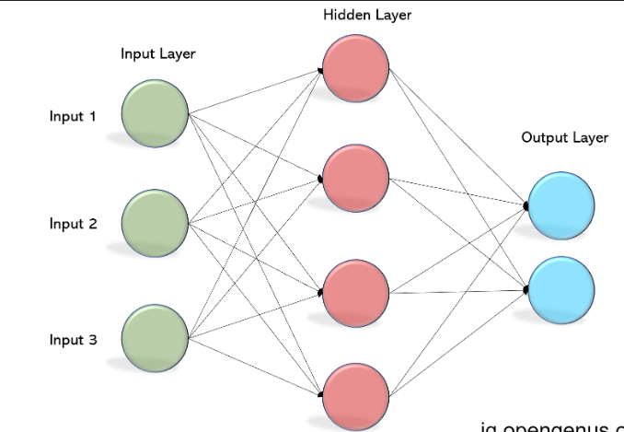

* In this network there an Input layer -> Hidden layer -> output layer
* Its perform’s super in Supervised problems such regression & Classification

**2. CNN – Convolution Neural Network**

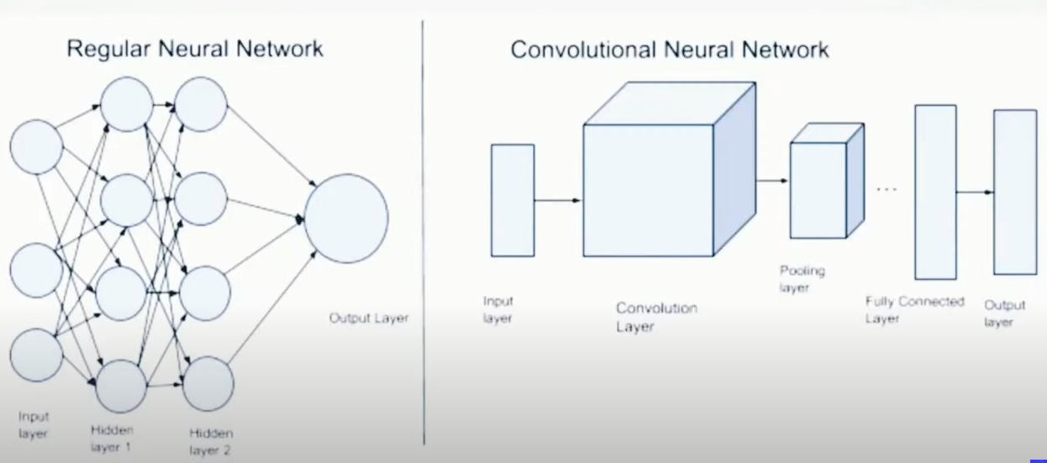

* This network much used in Image processing or video processing

3. Recurrent Neural Network

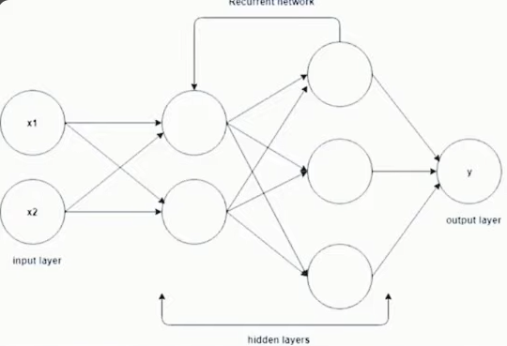

* Generally network are are trained from left to right But in RNN in the hidden layer the there will be loop for training
* LSTM is also used here
* Majorly this architecture used in LLM as chatbot

4. Autoencoder

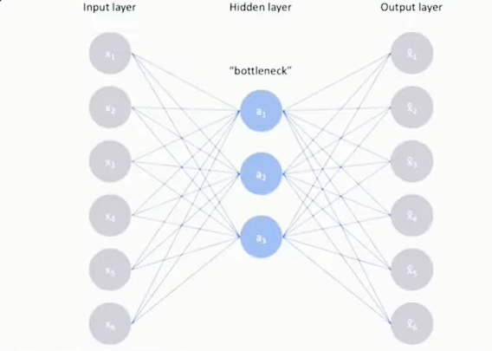

* This autoencoder are used for compressing and does not lose it quality while extracting

5. GAN Generative Adverserial Networks

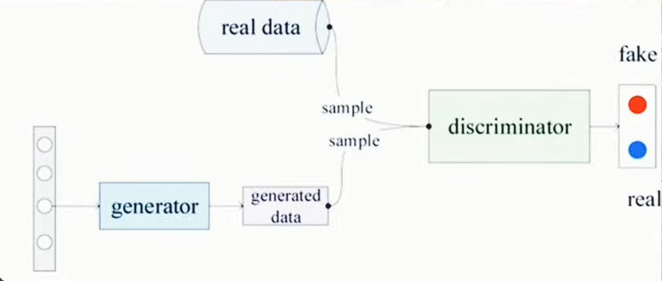

* This is used in generating the images,videos,music,text